

**Cloud Based Attendance System**

**PROJECT SYNOPSIS**

Cloud Based Attendance System

**BACHELOR OF TECHNOLOGY**

Computer Science Engineering

SUBMITTED BY

Akansh Verma (R110219006)

Aviral Mehra (R110219031)

Amish Choudhary (R110219008)

Vedant Sheoran (R177219198)

GUIDED BY

|  |  |  |  |  |
| --- | --- | --- | --- | --- |
| Name of the student | Akansh Verma | Aviral Mehra | Amish Choudhary | Vedant Sheoran |
| Class Roll No. | R110219006 | R110219031 | R110219008 | R177219198 |
| Address | 22, R K Puram, Dalanwala, Dehradun, Uttarakhand. [akanshverma20@gmail.com](mailto:akanshverma20@gmail.com), 9997772897 | 8, Nawab Yusuf Road, Civil Lines, Prayagraj-211001, aviralmehra08@gmail.com,7525810227 |  |  |
| Branch | B.Tech CSE(CCVT) | B.Tech CSE(CCVT) | B.Tech CSE(CCVT) | B.Tech CSE(AIML) |
| Batch | 26 | 26 | 26 | 26 |
| Proposed Topic | Cloud Based Attendance System | Cloud Based Attendance System | Cloud Based Attendance System | Cloud Based Attendance System |

Content Page

|  |  |  |
| --- | --- | --- |
| S. No. | Topic | Page No. |
| 1 | Introduction | 4 |
| 2 | Literature Survey | 5 |
| 3 | Methodology/Planning of work | 6 |

|  |  |  |
| --- | --- | --- |
| 4 | Facilities required and references | 7 |

**Introduction**

The Attendance Monitoring System is essential for each organization so as to check the performance of students and whether each and every student is present or not. In organizations attendance is taken manually by calling their registered Roll Numbers or names noted in attendance registers issued by their department heads as a proof. In some organizations the students are told to sign the sheets which are stored for future references. This technique is repetitive and leads to manual errors as few students regularly sign the sheets for their absent friends.

This method additionally makes it more complex to track all the student’s attendance and difficult to monitor the individual attendance in a big environment. In this we use are using the technique of face detection using Amazon Rekognition framework to continuously recognize students going to class and marking their attendance by comparing their faces with database to match and mark attendance. This facial biometric framework takes a picture of a person using camera and compares the image with the image which is stored at the time of enrolment and if the face matches it marks the attendance and monitors the student performance continuously.

This is a cloud-based attendance system which is developed with AWS and Python Programming Language. The project can be used for managing student’s records and attendance. The website will have a database constituting of student’s personal information and the courses they are enrolled in. Admin will have the access to the database and can update or delete the records. The database will be stored into AWS which will form connection between application and cloud server via internet connection. The students can view his/her attendance after they have logged into the system. This data is retrieved from the cloud database and can be accessed any time by the student and the admin. Admin can add new by registering the new student and fill up their registration details. The admin is authorized to view the records of all the students. This system allows to keep up to date record of the students.

AWS Services used –

Amazon S3:

Amazon Simple Storage Service (Amazon S3) is an object storage service that

offers industry-leading scalability, data availability, security, and performance.

AWS Rekognition:

Amazon Rekognition makes it easy to add image and video analysis to your

applications using proven, highly scalable, deep learning technology that

requires no machine learning expertise to use.

**Literature Survey –**

1. Mr. Sasi Kumar A N, Vasanth S, Surendar G, Vishnu J “Cloud based Attendance System for Students/Employees using CNN and LSTM” 2021 International Research Journal of Engineering and Technology (IRJET) Volume: 08 Issue: 06 e-ISSN: 2395-0056.

This paper outlines the problems faced by organizations which are maintaining attendance in handwritten format each day. The objective is to reduce the overall complexity in smart attendance system which is achieved using deep learning technique and hence by increasing the system performance.

1. Pravin Panditrao Chilme, Pathan Naserkhan Jaffarkhan “Face Recognition Based Smart Attendance System” 2020 International Journal of Computer Sciences and Engineering Vol.8, Issue.4 E-ISSN: 2347-2693.

This article describes the automated attendance management method. The project's key working theory is to identify and remember a particular student. This project is built for attendance at school / college. This framework is based on the technique for camera known as facial recognition system.

**Methodology/Planning of work**

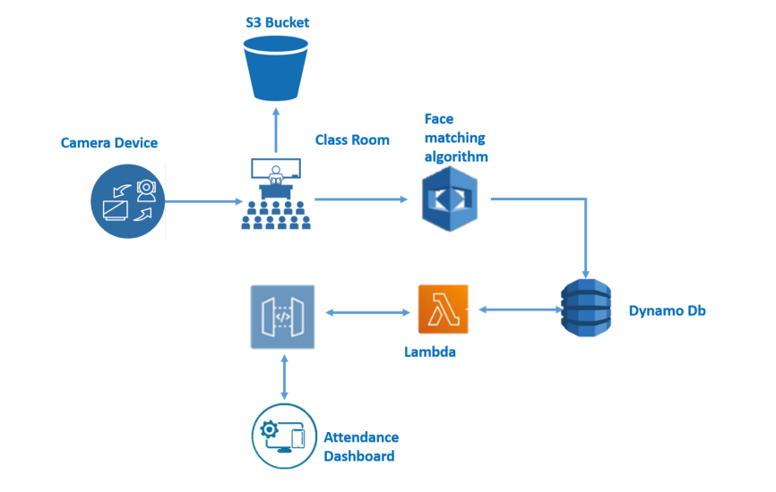

Architecture of the Project

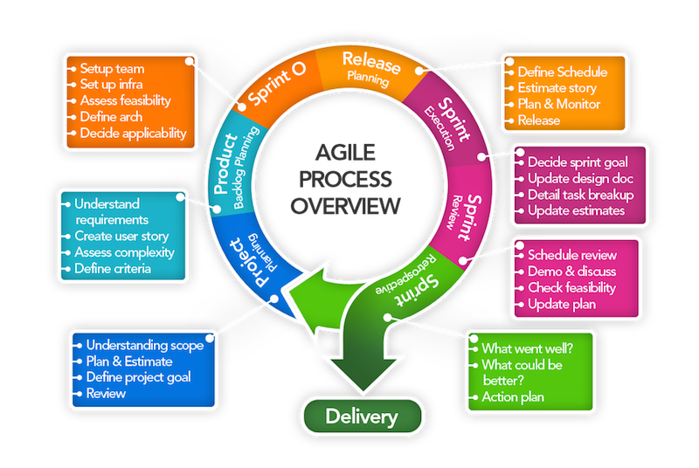

Workflow of the project

**Facilities required for proposed work**

Software requirements-

* Windows 7 or above
* AWS
* Visual studio 2010

Hardware components-

* Processor – Core i3 or above
* HDD –128 GB
* Memory – 2GB
* Internet Connection

The project needs an active internet connection and a camera or else the attendance won’t be recorded.

**References**

* https://www.irjet.net/archives/V8/i6/IRJET-V8I6165.pdf
* https://www.ijcseonline.org/pub_paper/16-IJCSE-07829-49.pdf